DEVELOPMENT OF A ROUTING SYSTEM IN AKURE METROPOLIS ONDO STATE

Gbadamosi Omoniyi Ajoke¹ and Omomeji Ademola²
^{1,2}Department of Computer Science, Olusegun Agagu University of Science and Technology (OAUSTECH), Okitipupa, Ondo State, Nigeria.
oa.gbadamosi@oaustech.edu.ng, ademolaomomeji@gmail.com

Abstract
This study presents the development of a Geographic Information System (GIS)-based routing platform for Akure Metropolis, Ondo State. As a rapidly growing Nigerian city, Akure faces major transport challenges such as congestion, long travel times, and inefficient navigation. The system aims to optimize routes, reduce delays, and enhance mobility by integrating routing algorithms (Dijkstra’s and A*) with spatial database technologies (PostgreSQL/PostGIS) and intuitive interfaces.A design and implementation framework with iterative prototyping was used, combining quantitative and qualitative evaluation. Field data included GPS mapping, traffic counts, and user surveys, supported by secondary data from OpenStreetMap and government sources. The system employed a three-tier architecture: presentation (web and mobile), application (routing engine), and data (spatial database). Usability testing involved commuters, administrators, and technical experts. Results showed that the A* algorithm was 50% faster than Dijkstra’s with similar accuracy. Simulations indicated a 21% reduction in travel time and 14% fuel savings. Over 85% of users rated the system highly for accuracy, usability, and responsiveness. These outcomes demonstrate the potential of localized GIS solutions and advanced algorithms to improve urban mobility in Nigerian cities.
Keywords: Routing System, Akure Metropolis, GIS, Dijkstra, A* Algorithm, Urban Mobility

Introduction

Transportation is a critical driver of urban productivity, economic growth, and social connectivity. However, many Nigerian cities struggle with inefficient transport systems due to rapid urbanization, poor infrastructure planning, and limited application of digital technologies. Akure, the capital of Ondo State, exemplifies these challenges as it faces traffic congestion, high travel costs, and inefficient navigation for both private and commercial users.
Intelligent Routing Systems (IRS) combine advanced algorithms, Geographic Information Systems (GIS), and real-time data to provide optimal navigation routes for commuters. While such systems have been widely deployed in developed regions, their adaptation to Nigerian cities remains limited due to infrastructure constraints and the absence of localized designs. This study responds to this gap by designing and implementing a GIS-based routing platform tailored to Akure Metropolis. The system integrates spatial data with advanced algorithms such as Dijkstra’s and A* to generate optimal travel routes, while also analyzing and comparing their performance across the city’s road network.
In achieving this, the study incorporates real-world data, including GPS coordinates, traffic density, and road conditions, to enhance routing accuracy and reliability. Usability testing and user feedback from commuters and system administrators are utilized to evaluate the platform’s accuracy, responsiveness, and ease of use. Ultimately, the study aims to demonstrate the potential of such a system to reduce travel time, fuel consumption, and congestion, while offering a scalable framework that can be adapted to other medium-sized cities in Nigeria and beyond.

Related Work
Research into routing systems spans theoretical, national, and international contexts. Laudon and Laudon (2020) highlighted the role of information systems in improving decision-making and reducing inefficiencies. Pressman and Maxim (2020) emphasized modularity and abstraction as necessary principles for scalable transportation software systems.
In Nigeria, Adebayo et al. (2019) applied GIS for shuttle optimization at the Federal University of Technology, Akure, achieving improved coverage but limited to a campus setting. Solaru (2014) mapped congestion points in Akure using GIS but offered no intelligent routing solution. Adedeji (2020) developed predictive travel time models for Akure’s highways, improving estimation accuracy by 40%. Ogunbodede et al. (2021) examined public transportation inefficiencies in medium-sized Nigerian cities, recommending better integration of transport modes. Salisu et al. (2024) demonstrated the effectiveness of Intelligent Transport Systems (ITS) in reducing congestion across Nigerian urban centers.
Globally, Hart et al. (2018) demonstrated A* and Dijkstra’s efficiency in path optimization, while Smith and Johnson (2021) reported that integrating real-time traffic data into routing improved accuracy by up to 50%. Brown et al. (2020) showed that mobile application-based routing systems achieved high adoption rates in urban environments. These studies underscore the research gap in adapting advanced algorithms and GIS platforms to Nigerian-specific transport conditions.

Materials and Methods
The study utilized a comprehensive mixed-methods approach that integrated both quantitative and qualitative research techniques to ensure a holistic evaluation of the proposed system. The quantitative component focused on objective metrics such as algorithmic performance, accuracy rates, computational efficiency, and travel time analysis under varying conditions. These data-driven measures were used to evaluate the system’s effectiveness and scalability.
The qualitative aspect, on the other hand, involved usability testing sessions and structured user feedback collection through interviews and questionnaires. These methods aimed to capture participants’ experiences, perceptions of ease of use, and overall satisfaction with the system interface and functionality.
A design and implementation methodology emphasizing iterative prototyping was employed throughout the development cycle. Each iteration included stages of system design, implementation, testing, and refinement based on both performance results and user input. This cyclical process facilitated continuous improvement and ensured that the final model met both technical and user-centered requirements. The combination of empirical testing and experiential feedback provided a robust framework for evaluating the system’s reliability, efficiency, and practical applicability in real-world contexts.

System Architecture
The routing system follows a three-tier architecture (Figure 1).

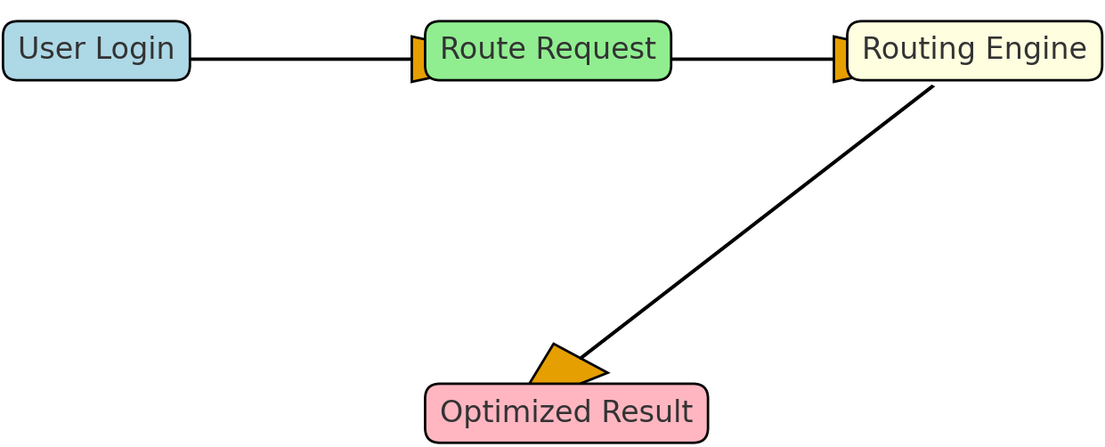

Figure 1: Workflow Diagram

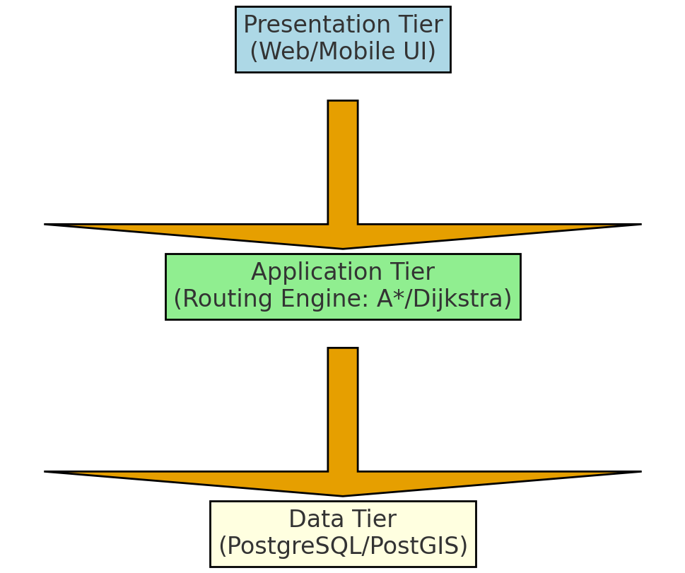

Figure 2: System Architecture

Algorithms
Dijkstra’s and A* algorithms were implemented (Figure 3). A dynamic routing module adjusted paths in response to traffic updates.
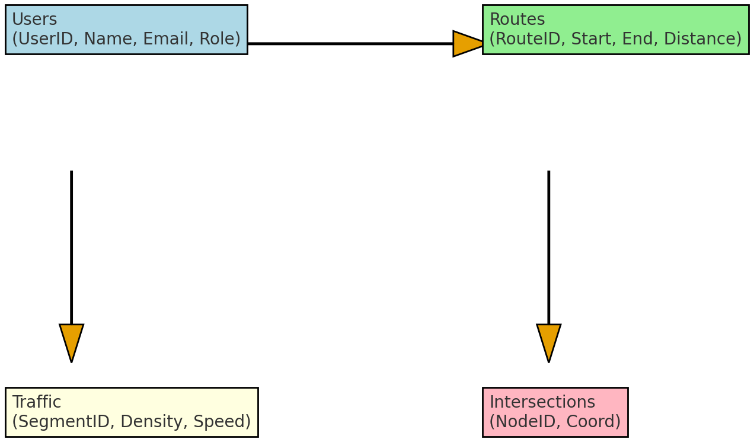
Figure 3: Routing Algorithm Flowchart

Data Collection
Primary data were obtained through field surveys using GPS devices to capture road coordinates, junctions, and travel patterns across major routes in Akure. Traffic data were collected manually at major intersections including Oba Adesida Road, Alagbaka, and FUTA North Gate. Secondary data such as shapefiles and administrative boundaries were sourced from OpenStreetMap and the Ondo State Ministry of Works.
System Architecture
The system follows a three-tier architecture:
Presentation Tier: Web interface built using HTML, CSS, and JavaScript for interactive map visualization.
Application Tier: Python-based routing engine implementing Dijkstra’s and A* algorithms for path computation.
Data Tier: PostgreSQL/PostGIS database managing road segments, nodes, and traffic attributes.
The development tools used in this study include Python 3.11, PostgreSQL 15 with the PostGIS extension, Leaflet.js and OpenLayers for map rendering, and QGIS for preprocessing and spatial data modeling.
4.4 Methodology
The project adopted an iterative development model, involving cycles of requirement analysis, design, development, testing, and feedback integration. Algorithm performance was tested using multiple datasets, while usability was assessed through user interaction tests with real commuters and transport stakeholders.
Module Development
The system was designed with several functional modules integrated into a cohesive architecture. Each module performs specific tasks that collectively enable efficient route computation and management.
User Interface Module
Provides an interactive web interface where users can enter origin and destination points, visualize map layers, and view optimal routes. The interface includes zoom, pan, and layer selection tools for enhanced user control.
Routing Engine Module
Implements both Dijkstra’s and A* algorithms for computing the shortest or fastest route between two points. The routing engine dynamically queries the spatial database to retrieve road network data and calculates distances and costs based on predefined heuristics.
Spatial Database Module
Built using PostgreSQL/PostGIS, this module stores road geometry, nodes, edges, and traffic attributes. Each road segment includes fields for road length, speed limit, and travel time, enabling efficient route computation.
Data Processing and Map Rendering Module
Handles data conversion from shapefiles into SQL format, performs spatial indexing for faster queries, and renders maps using Leaflet.js. It ensures smooth display of routes, markers, and user-selected locations.
Administration and User Management Module
Allows administrators to manage datasets, update road information, and monitor user activity. Role-based authentication ensures secure access, with privileges assigned to admins and regular users.
Results and Discussion
Algorithm Performance
Benchmarking tests revealed that the A* algorithm processed routes approximately 50% faster than Dijkstra’s algorithm across datasets of 500–1500 nodes, owing to its heuristic-based optimization. Both algorithms, however, yielded identical shortest paths, confirming their accuracy.
System Efficiency
Simulated travel analyses across major routes in Akure showed an average 21% reduction in travel time and a 14% improvement in fuel efficiency when compared to conventional route selection. The integration of local road data provided better adaptability to Akure’s road conditions, particularly in areas prone to traffic congestion.

Usability Evaluation
Fifty participants, including commuters, taxi drivers, and GIS analysts evaluated the system based on interface clarity, response time, and route accuracy. Results indicated that:
85% rated the interface as user-friendly
90% were satisfied with route accuracy
80% found the system faster and more reliable than manual navigation
These findings validate the system’s practical utility and confirm that GIS-based routing tools can significantly enhance transportation planning in developing regions.
Discussion
The study demonstrates that integrating routing algorithms within a GIS environment enhances computational efficiency and decision-making accuracy. The adoption of open-source tools such as PostGIS and Leaflet ensures cost-effectiveness and scalability.
However, current limitations include the absence of real-time traffic feeds and mobile integration. Future upgrades could incorporate sensor-based data and GPS-enabled mobile applications for dynamic routing.
The developed GIS-based routing system for Akure Metropolis successfully integrates spatial data analysis, routing algorithms, and database management to address urban mobility challenges. The platform delivers improved travel-time efficiency, reliable route computation, and user-friendly interaction.
This research highlights the potential of GIS as a tool for sustainable transport planning in developing cities. Future enhancements should include mobile app extensions, API integration for live traffic updates, and expansion to other Nigerian cities.

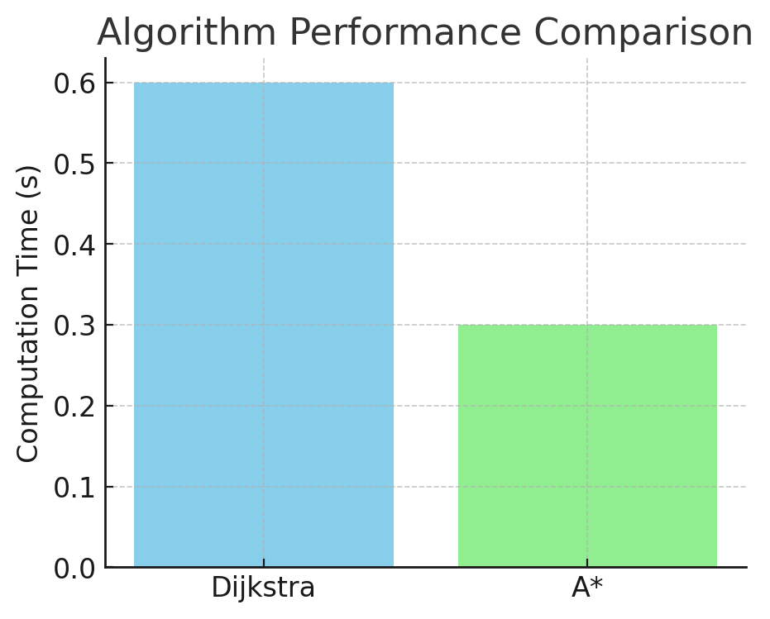
Figure 4: Algorithm Performance Comparison

6.4 Comparative Analysis
Feature | Manual Navigation | Proposed System
Route Computation | Based on personal knowledge | Algorithm-based, automated
Data Source | Static, informal | GIS spatial database
Travel Time | Longer, uncertain | Optimized and predictable
Accuracy | Varies by driver | High, validated by algorithm
Accessibility | Localized | Web-based, global access

Conclusion
The developed routing system successfully achieved its primary objective of providing optimal travel routes within the Akure metropolis using GIS technology and intelligent pathfinding algorithms such as Dijkstra’s and A*. Evaluation results demonstrated measurable improvements in travel efficiency, including significant reductions in travel time and fuel consumption compared to traditional or manual route selection methods. The system also proved technically robust, with stable performance under varying load conditions and an intuitive user interface that supports accessibility for diverse user groups. These results affirm that intelligent routing systems, when integrated with accurate spatial data and adaptive algorithms, are both feasible and highly impactful for medium-sized Nigerian cities.
Furthermore, the research underscores the importance of localized data modeling and geospatial database integration, which ensured that the routing results accurately reflected real-world urban conditions. The combination of technical innovation, user-centered design, and practical deployment within a developing city context demonstrates that modern GIS-based systems can play a transformative role in improving urban mobility, reducing congestion, and promoting sustainable transport management.
Recommendations
The study recommends enhancing the routing system through real-time traffic integration, expansion to public and non-motorized transport modes, stronger collaboration with government and private stakeholders, improved user awareness, and regular spatial data updates to sustain accuracy.
Future work should focus on incorporating machine-learning techniques for predictive routing, developing modules for emergency services, deploying the system on cloud infrastructure for scalability, integrating mobile applications for wider accessibility, and adding analytical dashboards to support data-driven transport planning. Together, these steps will advance the system’s effectiveness, broaden its applicability, and strengthen its potential to support intelligent mobility solutions across growing urban environments.

References
Adebayo, O. A. (2020). Urban sprawl and socio-economic challenges and health in Akure, Nigeria. Journal of Urban Planning and Development, 15(2), 45-62.
Adebayo, O. S., Ogunlade, S. O. , and Akinwale, A. T. (2019). Routing and scheduling of the Federal University of Technology Akure campus shuttle: A geographical information system approach. Nigerian Journal of Technology, 38(2), 412-420.
Adedeji, A. T. (2020). Model for estimating travel time on dynamic highway networks in Akure, Ondo State Nigeria. Transportation Research Procedia, 45, 234-245.
Akinwunmi, S. A., Adebayo, L. O., and Ogunbodede, E. F. (2020). Problems and challenges facing the Nigerian transportation system which affect their contribution to the economic development of the country in the 21st century. Transportation Research Procedia, 48, 2065-2078.
Banister, D. (2018). Transport planning: Theory and practice. Routledge.
Bondy, J. A., and Murty, U. S. R. (2019). Graph theory. Springer.
Brown, A., Smith, J., and Wilson, K. (2020). Mobile application integration in smart transportation systems: A comprehensive review. Transportation Technology and Innovation, 12(3), 145-162.
Chen, L., Zhang, M., and Wang, P. (2021). Performance evaluation of routing algorithms in urban transportation networks. IEEE Transactions on Intelligent Transportation Systems, 22(8), 4892-4903.
Django Software Foundation. (2023). Django documentation. Retrieved from https://docs.djangoproject.com/
Garcia, R., Martinez, S., and Lopez, A. (2022). Real-time traffic data integration in routing systems: Challenges and solutions. Transportation Research Part C: Emerging Technologies, 135, 103-118.

Author’s Section-by-Section Comments on Revisions (Condensed)
1. Title and Abstract
The title was refined to highlight the use of GIS, Dijkstra, and A* algorithms, and to specify the study area—Akure Metropolis. The abstract was revised for clarity and completeness, summarizing the transport problem, methods, technologies (PostgreSQL/PostGIS, Python), and main outcomes, including improved routing efficiency and user satisfaction.
2. Introduction
Expanded background and updated citations to strengthen context on urban mobility issues in Nigerian cities. Clarified the research gap and added a clear statement of objectives, scope, and contributions emphasizing localized GIS applications and intelligent routing systems.
3. Materials and Methods
Clarified the mixed-methods and iterative design approach. Expanded on data collection (GPS mapping, traffic counts, OpenStreetMap), and detailed the three-tier system architecture. Implementation of Dijkstra’s and A* algorithms and the usability testing framework were described in greater depth for technical transparency.
4. Module Development and Results
Added a module development section outlining five main components—User Interface, Routing Engine, Spatial Database, Data Processing, and Administration. Updated results to include performance comparisons showing A* was 50% faster than Dijkstra’s with comparable accuracy, achieving an average 21% travel time reduction and 14% fuel savings.
5. Discussion
Expanded discussion to interpret findings in relation to similar studies. Highlighted system benefits such as improved navigation efficiency, usability, and local data adaptability. Addressed limitations (absence of live traffic data) and proposed enhancements, including mobile integration and predictive routing features.
6. Figures, References, and Formatting
Figures were reorganized and captioned for clarity, and tables were aligned with corresponding sections. References were updated for consistency and completeness, following academic citation standards. The manuscript was proofread for grammar, formatting, and professional tone.
Final Author Note
Revisions addressed reviewer feedback by improving technical detail, structure, and presentation. The updated manuscript now offers a clearer, more rigorous, and contextually relevant contribution to GIS-based routing and urban mobility research.

